Control Panel
Ease of Access Center
Make the Keyboard easier to use
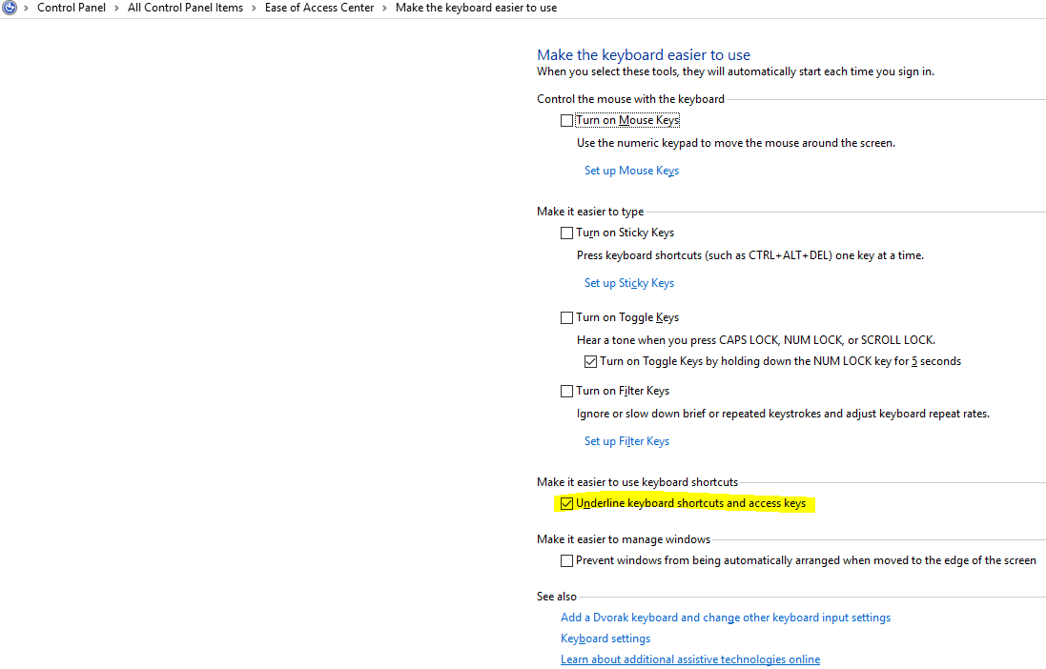
Or Control Panel
Personalization
Ease of Access Center
Keyboard
Other Settings – Enable Shortcut underlines
